Introducing supramolecular polymers to DNA nanotechnology
Yuliia Vyborna¹, Robert Häner* ¹
1 Department of Chemistry and Biochemistry, University of Bern Freiestrasse 3, CH-3012 Bern, Switzerland.
Email: yuliia.vyborna@dcb.unibe.ch
Self-assembly of DNA-containing molecules into biocompatible functional materials has attracted considerable attention over the last years. In this contribution, we present our recent findings in the field of self-assembled DNA conjugates and their potential applications as stimuli-responsive materials, cargo binding vehicles, and energy transfer platforms.¹ The DNA conjugates consist of a short oligonucleotide strand covalently bound to an array of phosphodiester-linked pyrenes. Depending on the strand composition and conditions, the self-assembly governed by the stacking and hydrophobic interactions between pyrenes leads to a variety of shapes: micelles, one-dimensional ribbons and two-dimensional nanosheets. In the case of 1D structures (DNA-grafted supramolecular polymers), the polymer core is formed by the stacked pyrenes, whereas the oligonucleotides are arranged at the edges of the ribbons in a comb-like fashion.
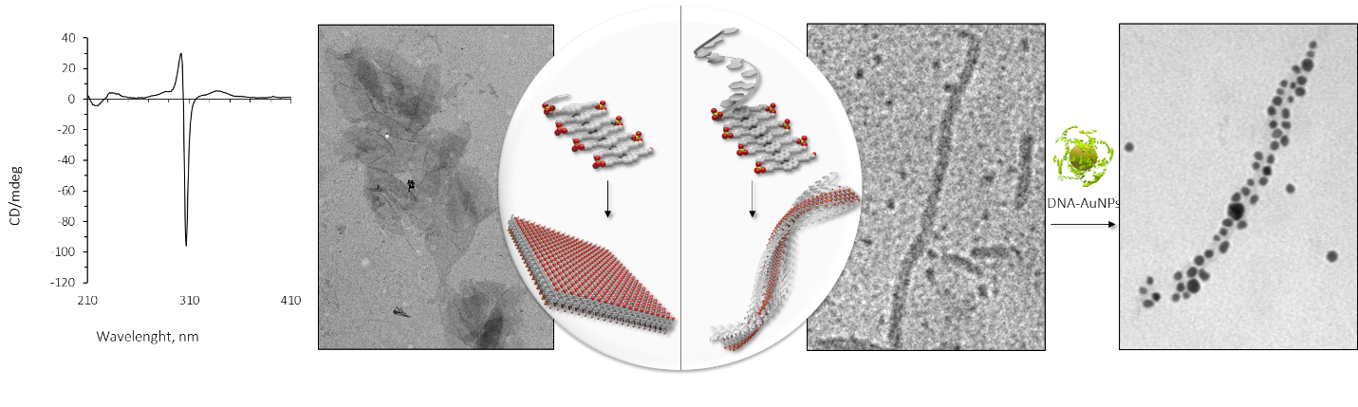
The ability to design interactions between oligonucleotides is central in mastering the properties of DNA-grafted supramolecular polymers.² For example, a helical array of AuNPs is created on the ribbons via sequence-specific DNA binding.³ Additionally, hybridization of the single-stranded DNAs from the ribbons with a complementary non-modified DNA strand leads to the formation of hierarchically organized networks.⁴ The transformation occurs in a highly cooperative manner, resembling certain biological processes. In the case of 2D structures, the assemblies exhibit unique chiroptical properties. Finally, our results suggest great opportunities towards potential applications in biosensing, complex carrier systems and functional nanoarchitectures. Our current attempts aim at integrating these oligonucleotide-based assemblies in the field of DNA nanotechnology.
[1] Vyborna, Y.; Vybornyi, M.; Rudnev, A. V.; Häner, R. Angew. Chemie Int. Ed. 2015, 54, 7934-7938.
[2] Vyborna, Y.; Vybornyi, M.; Häner, R. Bioconjug. Chem. 2016, 27, 2755-2761.
[3] Vyborna, Y.; Vybornyi, M.; Häner, R. Chem. Commun. 2017, accepted.
[4] Vyborna, Y.; Vybornyi, M.; Häner, R. J. Am. Chem. Soc. 2015, 137, 14051-14054.

