A Self-Developed and Constructed Robot for Minimally Invasive Cochlear Implantation
Running Head: Self-Developed Robot for Cochlear Implantation
*Brett Bell PhD^{1,2}, *Christof Stieger PhD^{1,3}, Nicolas Gerber MSc^{1,2}, Andreas Arnold MD^{1,3}, Claude Nauer MD⁴, Volkmar Hamacher⁵, Martin Kompis MD³, Lutz Nolte PhD^{1,2}, Marco Caversaccio MD^{1,3}, Stefan Weber PhD^{1,2}
¹ ARTORG Center, University of Bern, Switzerland
² Institute of Surgical Technology of and Biomechanics, University of Bern, Switzerland
³ Department of ENT, Head and Neck Surgery, Inselspital, University of Bern, Switzerland
⁴ Department of Neuroradiology, University Hospital Bern, Switzerland
⁵ Phonak Acoustic Implants, Stäfa, Switzerland
*Contributed equally to this publication
This paper was presented at the Collegium Oto-Rhino-Laryngologicum Amicitiae Sacrum, 5-7 September.2011, Bruges, Belgium.

Abstract
Conclusion: A robot built specifically for stereotactic cochlear implantation provides equal or better accuracy levels together with a better integration into a clinical environment, when compared to existing approaches based on industrial robots.
Objectives: To evaluate the technical accuracy of a robotic system developed specifically for lateral skull base surgery in an experimental setup reflecting the intended clinical application. The invasiveness of cochlear electrode implantation procedures may be reduced by replacing the traditional mastoidectomy with a small tunnel slightly larger in diameter than the electrode itself.
Methods: The end-to-end accuracy of the robot system and associated image-guided procedure was evaluated on 15 temporal bones of whole head cadaver specimens. The main components of the procedure were as follows: reference screw placement, cone beam CT scan, computer-aided planning, pair-point matching of the surgical plan, robotic drilling of the direct access tunnel, and post-operative cone beam CT scan and accuracy assessment.
Results: The mean accuracy at the target point (round window) was 0.56 ± 41 mm with an angular misalignment of 0.88 ± 0.41°. The procedural time of the registration process through the completion of the drilling procedure was 25 ± 11 min. The robot was fully operational in a clinical environment.

Keywords:
Computer-aided surgery, image-guided, navigation, key-hole

Introduction
Mastoidectomy is in the majority of cases the most time consuming and invasive component of a cochlear implantation procedure. Because the size of this cavity is much larger than what is physically required to insert the electrode (due to the need to proactively locate and respect risk structures) it embodies a significant potential for improvement.
Several surgical strategies have been proposed to reduce invasiveness by avoiding the traditional mastoidectomy such as the endomeatal [1], and transmeatal [2] approaches. More recently, an alternate approach was introduced by Warren et al [3], who suggest that the mastoidectomy can essentially be reduced to a tunnel slightly larger than the electrode diameter. Such a tunnel could provide a direct cochlear access (DCA) which, originates on the outer surface of the mastoid, passes through the facial recess, and terminates in the middle ear cavity in the region of the round window. Earlier work investigating the feasibility of an image-guided DCA found that accuracies below 0.5 mm are necessary to safely drill through the facial recess without damage to surrounding structures [4]. This accuracy level was, however, not possible to achieve using hand held instruments due to the inability to precisely position the surgical drill [5]. As a result, rigid patient-specific templates were developed to constrain the tool orientation to the planned path [6,7]. Though this approach was able to achieve an adequate accuracy (0.36 ± 0.18 mm), the latency involved in production and delivery of the template is problematic and it does not accommodate changes in surgical plan. Thus, industrial robots were also investigated as a means of accurately creating a DCA according to a pre-operative plan [8-10]. Although, these systems came close to the aforementioned accuracy goal of 0.5 mm, the size and weight of such machines makes them less suitable for integration into the operating room (OR).
Thus, a robot system was designed and built specifically for microsurgery on the lateral skull base with the goal of achieving: a) required technical accuracy, and b) requirements of clinical integration. The purpose of this study was to evaluate the target accuracy of this robotic system in a setting which closely matches the actual clinical conditions.

Materials and Methods

Robot System
The main component of the robot system is a five degree of freedom serial arm (see Figure 1{Formatting Citation}), which was optimized in terms of the overall weight (5.5 kg) and size (total arm length = 65 cm). The kinematic design allows the device to be mounted directly to the side of a standard OR table using standard adjustable arms (Fisso, Baitella AG, Switzerland). A built-in force-torque sensor (Mini-40, ATI, USA) at the robot end effector enables an intuitive haptic interaction effectively allowing the surgeon to move the tool tip to any desired position through a direct interaction. The robot is connected through two small cables to a controller placed well away from the sterile field. Additional equipment includes the head fixation system (FixIT, Medicon Medical Instruments, Germany), which rigidly fixes the patient’s head to the OR table, and a touch screen interface that allows the OR personnel to control the robot's actions and status. Additional technical information on the robot and its capabilities is described in [11].
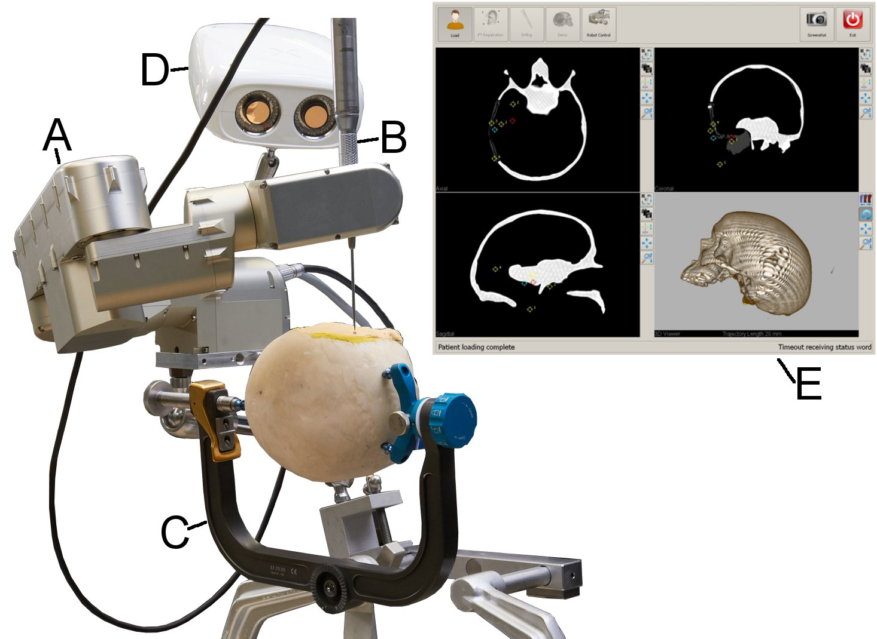
Figure 1: Overview of the robot navigation system. The robot (A), is mounted to the OR table. A conventional surgical drill (B) is attached to its end effector. The patient’s head is rigidly attached with a head clamp (C). An optical tracking system (D) can be used to verify the tool position. A touchscreen interface (E) allows the surgeon to control the robot and guides him through the entire surgical workflow. This interface additionally provides real time information regarding tool location in relation to the patient anatomy.

Study Protocol
8 anatomical whole head specimens preserved in Thiel solution were drilled bilaterally in this study (with permission of the Bernese cantonal ethical commission, KEK-BE 030/08). Each temporal bone region (left and right) was prepared for imaging by implanting 4 custom made titanium reference markers (a 1.5 × 5 mm screw, Medartis AG Switzerland, with an additional 4 mm titanium spherical head). These reference markers were later used to determine the location of the head during surgery using a paired-point matching algorithm, which represents the gold standard in terms of accuracy in the navigation literature [12].

Imaging and Planning
Previous work has shown that imaging resolution can have a direct impact on image-guided navigation accuracy [13,14]. Therefore, a flat-panel imaging device (NewTom VGi, Verona, Italy; also known as cone-beam CT or CB-CT) was utilized to acquire high resolution 3D images (Ø120 mm × 75 mm height, isotropic voxel size of 0.15 mm) of the temporal bone region.
A pre-operative surgical plan was created by segmenting structures: Facial nerve (FN), chorda tympani (ChT), external auditory canal (EAC), ossicles (Oss), and round window (RW, manual) using a commercial image analysis software tool (Amira, Visage Imaging Gmbh, Germany). The center points of each reference screw were also identified with a repeatability below 0.03 mm using a surface model matching algorithm [15]. Finally, a trajectory starting on the outer wall of the temporal bone and ending at the target location (RW) was manually planned using the center of the round window as the target point, and an entrance point on the surface of the temporal bone. The entrance point was chosen such that all risk structures were respected.

Robotic image-guided surgery
Each specimen was immobilized with the head clamp, and the robot was mounted to the OR table. The temporal bone region was then registered by digitizing the reference marker locations using the robot as a mechanical measurement device. These were located by visually aligning a registration pointer to the head of each marker screw. Finally, the bone around the entrance point was exposed in preparation for drilling.
The tunnel to the cochlea was drilled in two stages. First, a short, stiff spiral drill (Ø2.0 mm × 5 mm) was used to create a starter hole with a depth of 2 mm. This minimizes deflections caused by off-normal lateral drilling forces. Next, the full-depth tunnel was drilled using a Ø1.6 mm × 35 mm spiral drill (#60-16035, Stryker, Switzerland). The tool was cooled constantly during drilling with pure water with the drill rotating at 15,000 rpm and advancing at a rate of 0.25 mm/min.

Post-operative analysis
A post-operative CB-CT scan of the temporal bone region was acquired with a 1.6 mm titanium wire placed in the DCA. The corresponding pre/post-op CB-CT scans were then aligned using the reference screws. Next, the axis of the DCA was determined by segmenting the wire and fitting a line to the resulting point cloud using principal component analysis (MatLab, Mathworks, USA). The Euclidian distances to entry/target points and surface models of structures of interest were calculated. Suspected damage to risk structures was evaluated through manual dissection of the mastoid.

Results
15 direct cochlear access tunnels were drilled successfully in this study (one head only drilled on one side). Errors at entrance and target points were 0.44 ± 0.21 mm and 0.56 ± 0.41 mm respectively. Distances to other structures are also reported as the absolute distance measured post-operatively, and do not indicate the difference between the planned and actual values. The error angle between the planed and drilled trajectories was 0.88° ± 0.41°. The statistical measures from all 15 cases are compiled in Table I{Formatting Citation}.
Table I: Summary statistics from the drilling tests (n=15).
 |  |  | Distance Errors [mm] |  |  |  | Distances to
 | FRE | Entrance |  | Target |  | FN |  | EAC | ChT |  | Time [min] | Angle [°]
Max | 0.60 | 0.87 |  | 1.24 |  | 0.44* |  | 0.47* | 0.55 |  | 50.00 | 1.90
Min | 0.13 | 0.21 |  | 0.05 |  | 1.69 |  | 1.23 | 1.45 |  | 13.00 | 0.30
Ave | 0.36 | 0.45 |  | 0.56 |  | 0.49 |  | 0.20 | 1.00 |  | 25.38 | 0.88
STD | 0.11 | 0.21 |  | 0.41 |  | 0.54 |  | 0.53 | 0.64 |  | 11.96 | 0.4
Abbreviations: fiducial registration error (FRE), facial nerve (FN), external auditory canal (EAC), chorda tympani (ChT)
*Indicates a negative distance or penetration of structure.
Figure 2 shows the results of a case where the drilled tunnel matches closely with the plan. Of the 15 cases 3 had suspected facial nerve damage based on post-operative images. Subsequent mastoidectomy revealed that only one case was visibly damaged.
The time required for registration and drilling of each specimen was 25 ± 12 min. Initial tests required up to 50 min. but this time decreased with increasing experience. The time required to set the robot up was also recorded for every 4th test and averaged 10 minutes. Segmentation and trajectory planning was estimated to take 45 min to complete.
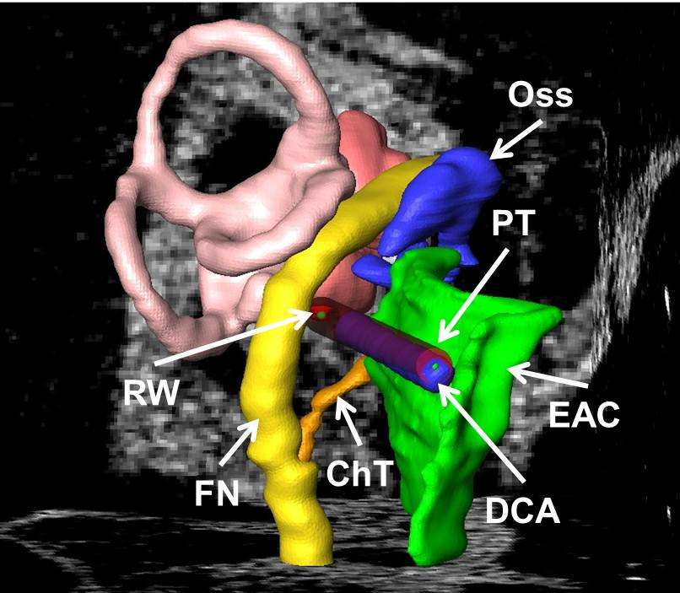
Figure 2: 3D representation of the planned tunnel (PT) compared to the achieved result (DCA). The pre-op plan consisted of the facial nerve (FN) the chorda tympani (ChT), the external auditory canal (EAC), and the ossicles (Oss).

Discussion
The main purpose of this study was to determine the accuracy of a purpose-built robotic system designed specifically for minimally invasive insertion of cochlear electrodes. The absolute target accuracy of the system was comparable to published work (see Table II{Formatting Citation}{Formatting Citation}{Formatting Citation}), but did not reach the 0.5 mm maximum error goal.
Table II: Comparison of DCA accuracy results.
Author / Year | Model | Error at Target [mm] | Method
Schipper 2004 ^{[4]} | Cadaver | 1.6 | Hand Guided
Labadie 2005 ^{[5]} | Temporal Bone | Not reported | Hand Guided
Labadie 2009 ^{[7]} | Temporal Bone | 0.36 ± 0.18 | Template
Majdani 2009 ^{[8]} | Temporal Bone | 0.78 ± 0.29 | Kuka KR3
Klenzner 2009 ^{[9]} | Temporal Bone | 0.25 (virtual) | Staeubli RX90CR
Baron 2010 ^{[10]} | Phantom | 0.62 ± 0.25 | Kuka KR3, Mitsubishi RV-3S
This Work | Cadaver | 0.56 ± 0.41 | Custom Built
Several factors possibly influencing the final accuracy have been identified. The registration process, which relied on visual alignment of the reference screws, introduced user and lighting dependent variability. This manual alignment technique will be replaced with a force-based semiautomatic screw digitization process that does not require user interaction.
The robot itself is also a significant error source. Laboratory tests indicate that the positioning error of the tool tip can be as high as 0.3 mm in a cubic workspace of 80 mm per side. Furthermore, we measured deflections of up to 0.2 mm for 10 N loads applied in various directions. Both the kinematic calibration errors and the robot stiffness can be corrected in the position controller, but require significant effort for implementation and testing. For this reason, we have decided to correct tool position using a precision optical tracking system (Cambar B1, Axios Gmbh, Germany) with a spatial accuracy of 0.01 mm in an 80 mm cubic volume. The tracking system mounts directly to the robot base for an immediate view of the surgical field as can be seen in Figure 1.
With a weight of only 5.5 kg, the system is easily handled and mounted to the OR table without the aid of special equipment. Furthermore, a direct connection of the robot to the OR table reduces the possibility of the patient’s head moving relative to it.
The average time required to register and drill a DCA (25 min) is an important component of clinical implementation. Interestingly, early procedural times were as high as 50 min, but reduced to as little as 13 min during later tests due to increased operator familiarity. We believe that reducing surgical time can have a positive outcome in light of lowering health care costs.
Future versions of a custom planning software tool should enable a more objective planning procedure by providing the user with information about distances of the proposed trajectory relative to risk structures along with the probability of hitting such structures. This information will also be used to exclude high-risk cases such as a narrow facial recess from a robotic intervention (a precaution not executed in this study).
In summary we presented a purpose built robotic system with end-target accuracy comparable with published approaches. We believe that integrating this system into existing facilities will be an efficient process due to the unobtrusive size and general design. Finally, we are confident that improvements in the planning procedure as well as robot positioning accuracy will allow the system to meet the necessary accuracy and safety goals.

Acknowledgements
This study was supported by the National Center for Competence in Research Computer Aided and Medical Guided Intervention, Switzerland (grant number NCCR S1NF40-111383), the Commission for Technology and Innovation, Switzerland (grant number KTI 9957.2), and Phonak Acoustic Implants (Lonay, Switzerland). We would like to thank Einar Nielsen, Dominik Widmer of the Interstaatliche Hochschule für Technik Buchs (Switzerland) for robot design support and Simon Roder, Jonas Salzmann, Fabio Paci, Daniel Widmer from the ARTORG Center for Hardware/Software development and data acquisition.
Declaration of interest: The authors report no conflicts of interest. The authors alone are responsible for the content and writing of the paper.

References
[1] Häusler R. Cochlear implantation without mastoidectomy: the pericanal electrode insertion technique. Acta Otolaryngol 2002;122:715–719.
[2] Kronenberg J, Baumgartner W, Migirov L, Dagan T, Hildesheimer M. The suprameatal approach: an alternative surgical approach to cochlear implantation. Otol Neurotol 2004;25:41-44.
[3] Warren FM, Balachandran R, Fitzpatrick JM, Labadie RF. Percutaneous cochlear access using bone-mounted, customized drill guides: demonstration of concept in vitro. Otol Neurotol 2007;28:325-329.
[4] Schipper J, Aschendorff A, Arapakis I, Klenzner T, Teszler CB, Ridder GJ, et al. Navigation as a quality management tool in cochlear implant surgery. J Laryngol Otol 2004;118:764-770.
[5] Labadie RF, Chodhury P, Cetinkaya E, Balachandran R, Haynes DS, Fenlon MR, et al. Minimally invasive, image-guided, facial-recess approach to the middle ear: demonstration of the concept of percutaneous cochlear access in vitro. Otol Neurotol 2005;26:557.
[6] Balachandran R, Mitchell JE, Blachon G, Noble JH, Dawant BM, Fitzpatrick JM, et al. Percutaneous cochlear implant drilling via customized frames: An in vitro study. Otolaryngol Head Neck Surg 2010;142:421–426.
[7] Labadie RF, Mitchell J, Balachandran R, Fitzpatrick JM. Customized, rapid-production microstereotactic table for surgical targeting: description of concept and in vitro validation. Int J Comput Assist Radiol Surg 2009;4:273–280.
[8] Majdani O, Rau TS, Baron S, Eilers H, Baier C, Heimann B, et al. A robot-guided minimally invasive approach for cochlear implant surgery: preliminary results of a temporal bone study. Int J Comput Assist Radiol Surg 2009;4:475–486.
[9] Klenzner T, Ngan CCC, Knapp FBB, Knoop H, Kromeier J, Aschendorff A, et al. New strategies for high precision surgery of the temporal bone using a robotic approach for cochlear implantation. Eur Arch Otorhinolaryngol 2009;266:955–960.
[10] Baron S, Eilers H, Munske B, Toennies J, Balachandran R, Labadie R, et al. Percutaneous inner-ear access via an image-guided industrial robot system. Proc Inst Mech Eng H 2010;224:633–649.
[11] Bell B, Gerber N, Gavaghan K, Stieger C, Caversaccio M, Weber S. Computerassistierte Präzisionschirurgie am Ohr. Automatisierungstechnik 2011;in press.
[12] Maurer CR, Fitzpatrick JM, Wang MY, Galloway RL, Maciunas RJ, Allen GS. Registration of head volume images using implantable fiducial markers. IEEE Trans Med Imag 1997;16:447-62.
[13] Bartling SH, Leinung M, Graute J, Rodt T, Dullin C, Becker H, et al. Increase of accuracy in intraoperative navigation through high-resolution flat-panel volume computed tomography: experimental comparison with multislice computed tomography-based navigation. Otol Neurotol 2007;28:129.
[14] Majdani O, Bartling SH, Leinung M, Stöver T, Lenarz M, Dullin C, et al. A true minimally invasive approach for cochlear implantation: high accuracy in cranial base navigation through flat-panel-based volume computed tomography. Otol Neurotol 2008;29:120.
[15] Zheng G, Gerber N, Widmer D, Stieger C, Caversaccio M, Nolte L-P, et al. Automated detection of fiducial screws from CT/DVT volume data for image-guided ENT surgery. Conf Proc IEEE Eng Med Biol Soc 2010;1:2325-8.

Correspondence: Marco Caversaccio,MD, Chairman and Director of Department of Otorhinolaryngology-Head and Neck Surgery, Inselspital, University of Bern, Freiburgstrasse, CH-3010 Bern, Switzerland. Tel: _/41 31 632 41 74. Fax: _/41 31 632 49 00. E-mail: marco.caversaccio@insel.ch

