Jan Hermann, Fabian Mueller, Stefan Weber, Marco Caversaccio, Gabriela O’Toole Bom Braga*
Safety and Efficacy of Screw Placement for Pediatric Image-Guided Surgery
______
*Corresponding author: Fabian Müller: ARTORG Center for Biomedical Engineering Research, Murtenstrasse 50, Bern, Switzerland, e-mail:fabian.mueller@artorg.unibe.ch
Jan Hermann, Fabian Müller, Daniel Schneider, Gabriela O’Toole Bom Braga, Stefan Weber: ARTORG Center for Biomedical Engineering Research, Murtenstrasse 50, Bern, Switzerland
Marco Caversaccio: Department of Otorhinolaryngology, Head and Neck Surgery Inselspital, University Hospital Bern

Abstract: Retrospective study for fiducial screw placement for Image Guided Surgery in pediatric subjects.
Keywords: image-guided surgery, pediatric, robotics, screw placement, skull thickness, cortical layer.
- Introduction
Current high-accuracy image-guided systems for otologic surgery use fiducial screws for patient-to-image registration. Thus far, these systems have only been used in adults, and the safety and efficacy of the fiducial screw placement has not yet been investigated in the pediatric population.
- Methods
- The temporal bone separated into anatomical regions.
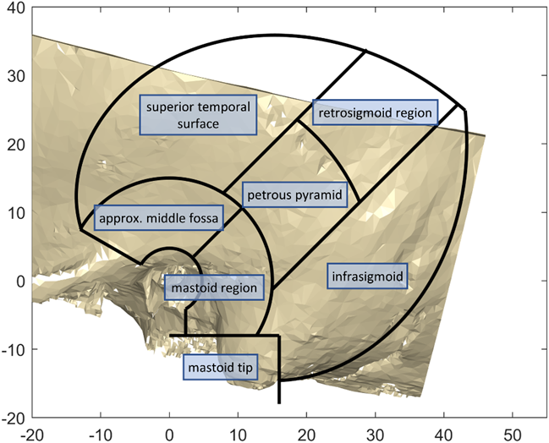
In a retrospective study, CT image data of the temporal region from 11 subjects meeting inclusion criteria (8-48 months at the time of surgery) were selected, resulting in n=20 sides. These datasets were investigated with respect to screw stability efficacy in terms of the cortical layer thickness (CLT), and safety in terms of the distance of potential fiducial screws to the dura mater or venous sinuses (DDVS). All of these results are presented as distributions, thickness colour maps, and with descriptive statistics. Seven regions within the temporal bone were analyzed individually (Figure 1). In addition, four fiducial screws per case with 4 mm thread-length were placed in an additively manufactured model according to the guidelines for robotic cochlear implantation surgery. For all these screws, the minimal distance to the dura mater or sigmoid sinus was measured, or if applicable how much they penetrated these structures.
- Results
In the virtual reconstructed temporal bone models, the cortical layer has been found to be mostly between 0.7 – 3.3 mm thick (from the 5th to the 95th percentile), while even thinner areas exist. The distance from the surface of the temporal bone to the dura mater or the venous sinuses varied considerably between the subjects and ranged mostly from 1.1 – 9.3 mm (from the 5th to the 95th percentile - Figure 2). From all 80 placed fiducial screws of 4 mm thread length in the pediatric subject younger than two years old, 22 touched or penetrated either the dura or the sigmoid sinus. The best regions for fiducial placement would be the mastoid area and along the petrous pyramid in terms of safety. In terms of efficacy, the retrosigmoid followed by the petrous pyramid, and infrasigmoid regions are most suited.
- Discussion
Due to the anatomical situation on the pediatric calvarium, the manufacturer’s guidelines for screw positioning in adults had to be adapted to children. The mastoid tip actually has the lowest median cortical layer thickness, and a high median safety distance. However, in children the mastoid tip cannot be used as a screw placement due to the anatomical position of the facial nerve that is exposed until 2 years of age. This way, the screw placement had to be shifted to a more superior position, where the skull density (cartilaginous parts and not fully-ossified bones) create an additional obstacle. Causing the more superior screw to be often localized in the middle fossa region. Furthermore, to keep accuracy, a certain distance between the screws must be respected. Creating a smaller area for middle ear access trajectory placement in IGS surgery, while obeying the limits posed by the facial recess and cochlear angles on this age group. Although the mastoid bone itself present adequate thickness for the screws [1], the surrounding temporal bone is still not fully formed, so care must be taken to preserve enclosing anatomy. Especially the dura, sigmoid and transverse sinuses are at risk. Measurements of the positions of these structures are usually done with the aid of computed tomography, but excessive exposure to children to ionizing radiation should be avoided. The use of point-of-care ultrasound (POCUS) have also been mentioned in literature [2, 3] for fracture determination and bone-anchored hearing aid placement with promising results. The use of this technology can assist in screw placement for pediatric subjects before screw implantation.
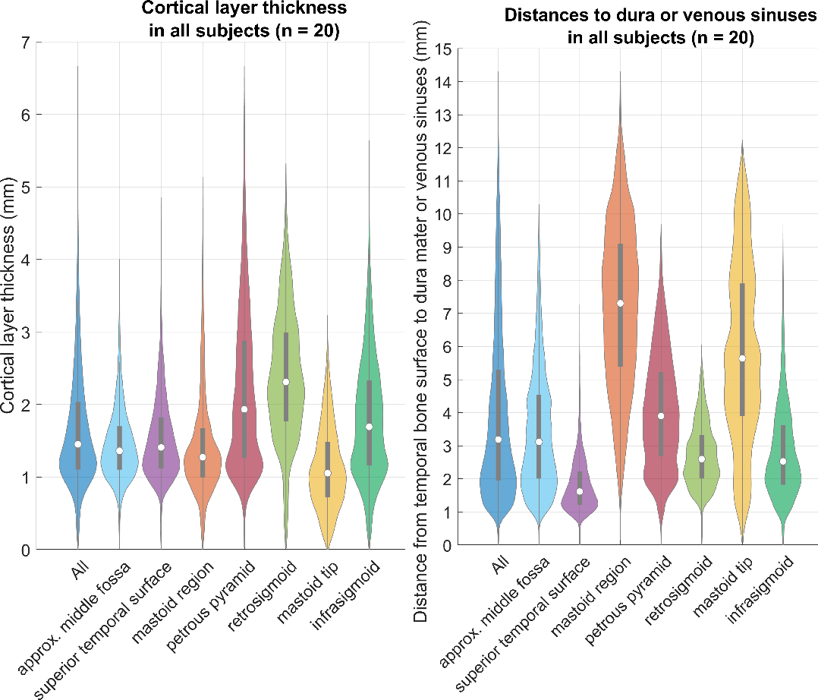
The results show thin cortical layers in this pediatric population, which are mostly 0.6 – 3.2 mm thick (from the 5th to the 95th percentile) in the region of interest for screw placement across all subjects. Even if only the thickest regions (i.e. retrosigmoid, petrous pyramid, infrasigmoid) are considered, the thickness values are still in a similar range. Hence, it is likely that a thin cortical layer is encountered during screw placement, and the screws could become loose during surgery, leading to navigational errors and potentially dangerous situations. The results of the distance to dura mater or the venous sinuses are mostly 1.1 – 9.3 mm with a median of 3.3 mm. Thus, the screw placement with the thread lengths of the current IGS systems (i.e. around 4 mm) run into the risk of penetrating the dura mater or venous sinuses.
- Violinplots of the CLT on the left, and the DDVS on the right. The gray bars within the violinplots are the lower and upper quartiles, and the white circle is the median value.
This study demonstrated potential damage to the dura and venous sinuses in all screw positions for the pediatric population with the currently used fiducial screws and screw placement guidelines. The measurements taken show thin cortical layers, and short distances from the temporal bone surface to the delicate anatomy underneath. The experiment where screws were placed in 3D-printed temporal bones according to guidelines by a surgeon resulted in 22 out of 80 fiducial screws in the area where the dura mater or venous sinuses would be, further solidifying the evidence of the potential risk. Screws for the pediatric population would need to be significantly smaller, and it is questionable if screws of this size would be effective in practice. Longer screws could be used if some screw placement workflow exists where there is prior information about safety and efficacy, i.e. when the bone thickness is measured beforehand. This could be achieved using image-guided navigation that has been registered through an initial coarse surface-matching technique, or other measurement technology such as ultrasound
- Conclusion
The current fiducial screws and the screw placement guidelines for adults are insufficiently safe or effective for pediatric patients.

Author Statement
Research funding: The author state no funding involved. Conflict of interest: Authors state no conflict of interest. Informed consent: Informed consent has been obtained from all individuals included in this study. Ethical approval: The research related to human use complies with all the relevant national regulations, institutional policies and was performed in accordance with the tenets of the Helsinki Declaration, and has been approved by the authors’ institutional review board or equivalent committee.

References
- Bom Braga OG, Schneider D, Muller F, Hermann J, Weber S, Caversaccio M. Feasibility of Pediatric robotic cochlear implantation in phantoms. Otol Neurotol 41:e192-e200, 2020.
- Parri N, Crosby BJ, Mills L et al. Point-of-care ultrasound for the diagnosis of skull fractures in children younger than two years of age. J Pediatr 2018;196:230-6.
- Stölzel K, Bauknecht C, Wenecke K, Schrom T. Sonographic determination of the calotte thickness. Laryngorhinootologie. 2007 Feb;86(2):107-11.

