Influence of directionality and maximal power output on speech understanding with bone anchored hearing implants in single sided deafness
Accepted for publication in:
European Archives of Oto-Rhino-Laryngology and Head & Neck
08-May-2013

Silvia Krempaska, M.D. ¹⁾, Juraj Koval, M.D. ¹⁾, Christoph Schmid ²⁾, Flurin Pfiffner Ph.D. ²⁾, Anja Kurz, M.Sc. ²⁾, Martin Kompis, MD, PhD ²⁾
¹⁾ Department of ENT, University of Kosice, Slovakia
²⁾ Department of ENT, Head and Neck Surgery
Inselspital, University of Berne, Switzerland

Correspondence and reprint requests:
Martin Kompis, MD, PhD
Department of ENT, Head and Neck Surgery
Inselspital
University of Berne
CH - 3010 Bern
Switzerland
Phone: +41 31 / 632 29 28
Fax: +41 31 / 632 31 93
email: martin.kompis@insel.ch

Abstract

Bone anchored hearing implants (BAHI) are routinely used to alleviate the effects of the acoustic head shadow in single sided sensorineural deafness (SSD). In this study, the influence of the directional microphone setting and the maximum power output of the BAHI sound processor on speech understanding in noise in a laboratory setting was investigated. 8 adult BAHI users with SSD participated in this pilot study. Speech understanding in noise was measured using a new Slovak speech in noise test in two different spatial settings, either with noise coming from the front and noise from the side of the BAHI (S₉₀N₀) or vice versa (S₀N₉₀). In both spatial settings, speech understanding was measured without a BAHI, with a Baha BP100 in omnidirectional mode, with a BP100 in directional mode, with a BP110 power in omnidirectional and with a BP110 power in directional mode. In spatial setting S₉₀N₀, speech understanding in noise with either sound processor and in either directional mode was improved by 2.2 to 2.8 dB (p=0.004…0.016). In spatial setting S₀N₉₀, speech understanding in noise was reduced by either BAHI, but was significantly better by 1.0 to 1.8 dB, if the directional microphone system was activated (p=0.046), when compared to the omnidirectional setting. With the limited number of subjects in this study, no statistically significant differences were found between the two sound processors.

Key Words Bone anchored hearing aids; Baha; unilateral hearing loss; BAHI; BP100; BP110 Power; speech understanding in noise; single sided deafness
Introduction
BAHIs are bone conduction hearing aids where sound transmission to the skull and, ultimately, to the inner ear is achieved through a titanium implant behind the ear [1]. BAHIs have been used for over 30 years. They have been shown repeatedly to be beneficial for patients with conductive or mixed hearing loss [e.g. 2, 3], even in the long term [4].
In addition, BAHIs have been used for more than a decade to compensate for the acoustic head shadow in as single sided sensorineural deafness (SSD) [5]. Advantages of BAHI in unilateral hearing loss have mainly been documented for adults [6], and even older adults [7]. Especially in a classroom setting the advantages of hearing aids for children with unilateral hearing loss are well known [8,9,10]
Until recently, only relatively simple BAHI sound processors with only a few possibilities for adjustments were available: the Baha Divino with a user controllable directional microphone system [11] and the Baha Intenso with only one omnidirectional microphone but with a higher maximal power output (MPO) [12]. Today, two more flexible processors, the BP100 [11] and the Baha BP110 power with a higher MPO are available. Both feature a 10-channel audiologist adjustable gain and compression and a directional multi-microphone noise reduction system.
The effect of directional microphone systems on speech understanding with BAHI in users with SSD is complex and not yet fully understood. After the two microphone signals are processed to form a directional system, the actual directionality is further modified by the nearby head of the user. Through the output of the BAHI, the processed directional signal is added directly acoustically to the signal, as heard though an unaided ear of the user with its own, individual and frequency dependent directionality. Furthermore, the BAHI processor is typically slightly tilted laterally due to the rounding of the skull. As BAHIs are placed behind the ear, it is known that more signals can be picked up from the rear than from the front, if an omnidirectional microphone is used [11].
So far, the effect of directional microphones and higher MPO in BAHI users with SSD has been addressed scientifically only in part. Theoretical considerations and preliminary reports suggest that lower transcranial attenuations or, instead of that, BAHIs with higher gains and higher MPO should improve speech understanding in SSD [13,14]. So far experimental data to confirm this hypothesis remain rare. To our knowledge, the decision between a medium power BAHI or a high power device are handled differently at different centres and possibly on the basis of individual preference.
Regarding SSD and directional microphones in BAHI, there is a study which considers target signal coming only from the front and in which the older Baha Divino is used [15]. It shows the directional microphone to be beneficial. However, it is conceivable, that for noise from the front, such a directional system might actually decrease speech understanding. Meanwhile, a recent study suggests that newer processors (such as the BP100) give more benefit to BAHI users with SSD than the older Baha Divino [16].
The choice of the device with the more beneficial MPO and the adjustment of the device with the more beneficial directionality are of practical relevance to the user.
In this pilot study, we aim to investigate 3 possible effects of BAHI in SSD with current sound processor technology: (1) the effect of sound processors with higher or lower MPO, (2) the effect of directional microphones in a setting, where BAHIs are expected to provide a benefit. i.e. noise from the front and speech from the side of the BAHI (S₉₀N₀) and (3) the effect of directional multi-microphone noise reduction systems when noise comes from the side of the BAHI (S₀N₉₀), i.e. in a setting where BAHIs are expected to be detrimental to speech understanding.

Materials and methods
Subjects
8 adult subjects, ages 29–59, mean 49.1 year, 2 female, 6 male, participated in the study. All had had a substantial sensorineural deafness in one ear for (duration 1-15 years, mean 7.0 years). They used either a BP100 (6), a Baha Intenso (1), or a Divino (1) on the side of their deaf ear (5 right, 3 left) for 3 months to 4 years (mean 1.3 years). Figure 1 shows a synopsis of their unaided hearing thresholds.

Study devices and fitting
Each participant was fitted with a Cochlear Baha BP100 and with a Cochlear Baha BP110 Power sound processor explicitly for this study. For both sound processors, the first fit suggested by the Cochlear fitting software version 2.0, based on the “BC Direct” threshold measurement [17], performed directly through the processor, was used. The “SSD”-setting of the fitting software, which introduces an attenuation for low frequency signals [18], was chosen. 2 program slots were activated. In program 1, microphones were set to “omnidirectional”, in program 2 to “fixed directional”. Position compensation and feedback cancellation were active in both program slots. In 3 subjects, feedback occurred with this first fitting with the BP110. It was controlled by reducing the gain above 4000Hz in one subject, and by reducing gain at low and at high frequencies in the other two subjects. There were no feedback issues with any fitting of the BP100. Subjects used the study devices only for the duration of the measurements described in the study protocol below. They were not allowed to keep them after the measurements.
Figure 2 shows examples of transfer functions for a BP100 and a BP110 processor in directional and in the omnidirectional mode from the front and from the side of the BAHI. The measurement was taken in a room of 5.16 x 5.94 x 3.40 m with an average reverberation time of 0.22 s (250-8000 Hz), and white noise at 70 dBA (71 dB SPL) presented by a loudspeaker (MT160D, Elettronica Montarbo s.r.l., Bologna, Italy) at a distance of 1 m, resulting in an estimated direct to reverberant ratio of +6.9 dB. The mechanical output signal of the Baha devices was measured by a skull simulator [19]. Both sound processors were programmed on the basis of an assumed direct bone conduction (BC) threshold of 35 dB at all frequencies with P1 in omnidirectional, and P2 in directional mode. Figure 2 shows the relative output of the 8 measurements (2 processor types x 2 directions of sound arrival x 2 directionality modes). The 0 dB line denotes the average of all 8 measurements. The differences between the output in the directional and the omnidirectional mode are greater at 90° than at 0° for both sound processors, indicating the directional effect at 90°. There is also a difference between the (higher) output levels of the BP110 and the (lower) levels of the BP100. According to the manufacturer, both processors have roughly the same output for same hearing loss, provided BC thresholds are close to normal (0 dB) and the input levels are reasonably low. However, for combinations of poorer BC-thresholds and relatively high input levels, as used here, there may be considerable differences.

Study protocol
The study has been approved by the ethical committee of the University of Kosice and has been performed in accordance with the Declaration of Helsinki. All participants gave their informed consent prior to inclusion in the study.
After pure tone audiometry (Fig. 1), the transcranial attenuation of each participant was estimated as the difference between the bone conduction thresholds measured without masking with the bone vibrator placed at either side of the head [20]. Then speech-in-noise tests were performed using a novel Slovak test. This test consist of 30 lists of 15 test items, where each test item consists of an introductory phase (“repeat the word...”) and a test word. The test items are presented in the presence of a CCITT (Comité Consultatif International Téléphonique et Télégraphique) speech spectrum noise signal. The noise level is fixed at 70 dBA (72 dB SPL) for the entire test. The level of the first test word is of each list is 76 dBA. The level of each following test item is decreased by -2 dB, if the last test word was repeated correctly, or increased by +2 dB, if it was not correct. The average presentation level of the last 9 test items (7 through 15) plus the level, which would be used for a virtual 16th test item are averaged to calculate the estimated signal-to-noise ratio (SNR) necessary for 50% speech understanding. The estimated slope of the discrimination function is 14% / dB.
All measurements were performed the sound field with speech and noise coming from two spatially separated loudspeakers [21]. Two spatial settings, S₀N₉₀ and S₉₀N₀ as shown in figure 3, were used. The test room at the ENT-Department of the University hospital of Kosice had a Volume of 27 m³ and an almost frequency independent reverberation time of 0.13 s (250-4000 Hz). Two loudspeakers (Type 1C, Behringer Inc, Willich, Germany) were placed at a distance of 1.2 m in front and at the BAHI side of the subject, respectively. Subjects sat on a chair and were instructed to face the front loudspeaker.
10 tests in 3 groups were performed with each subject. Each test consisted of two test lists, the results of which were averaged. In the first group of tests, speech understanding was tested without a BAHI in both spatial settings. In the second group of tests, speech understanding in noise was tested with a BP100 with the directional microphone switched on and off. In the third group, the same tests were performed with the BP110. The order of the groups of tests and the order of the tests within the groups were systematically varied to minimize effects of learning or fatigue. As a consequence, half of the participants were tested first with the BP100, the other half with the BP110 Power.

Statistical analysis
Results were analyzed by a certified statistician (M.K.) using InStat 3.10 (GraphPad Inc., La Jolla, Ca, USA) and Past 2.16 (University of Oslo, Norway) for the non-parametric-ANOVA (NP-ANOVA) analysis.

Results
Figure 4 shows the results of the speech in noise test. Results are shown as improvement in signal-to noise ratio (SNR) with Baha, when compared to the situation without Baha. Positive values denote an advantage with Baha.
In spatial setting S₉₀N₀, there is a statistically significant advantage between 2.2 and 2.8 dB for both speech processors and for both the directional and the omnidirectional microphone settings (p= 0.004…0.016, Wilcoxon signed rank test). There is no significant difference between the 4 conditions tested (Two-way-NP-ANOVA: p>0.55 for both factors and their interaction).
In spatial setting S₀N₉₀, where noise arrives from the side of the BAHI, the expected deterioration in speech understanding due to the BAHI can be found. It is larger and statistically significant if the microphone setting is omnidirectional (-2.0 and -1.7 dB; p=0.023 and 0.039) and smaller and statistically non significant for the directional setting (-0.2 and -0.7 dB, p=0.32 and 0.16). Two-way NP-ANOVA shows a significant difference for the factor “directionality” (p=0.046) but not for “processor type” or interaction.
It was analyzed, whether any of the effects of a BAHI depicted in fig. 4 depend systematically on the unaided hearing ability of the subjects. To this end, the
(a) average BC thresholds of the better hearing ear and (b) the transcranial attenuation was calculated for each subject over a frequency range of 500 to 4000 Hz. Linear correlations between these two parameters and each of the 8 improvements or deteriorations due to a BAHI shown in Fig. 4 were calculated. All of the 16 resulting correlation coefficients tended to be low (r²=0.0005 to 0.39) and even before corrections for multiple testing, none of the slopes differed significantly from 0 (p=0.10…0.96). The highest positive correlations were found between the BC-thresholds of the better ears and the gain with the BP100 and the BP110 in the directional mode and the setting S₉₀N₀ (r²=0.25 and 0.39; p= 0.21 and 0.10)

Discussion
In several aspects, our data reproduces and confirms results from earlier studies [e.g. 18,22,23]. We find a consistent benefit in terms of speech understanding in noise between 2.2 and 2.8 dB and a smaller, but reproducible disadvantage if noise comes from the side of the BAHI.
The number of subjects in this study was limited by the number of the subjects available at the study centre. As a consequence, the statistical power is also limited. While large effects can be found within this group and can be statistically significant even for N=8, smaller effects may be missed in this study.
The aim of this study was to look for three effects, only one of which (better speech understanding in the directional microphone in the S₀N₉₀ setting) was found. The other two effects (a benefit of the BP110 Power over the BP100 and a decrease in speech understanding for the directional mode in S9₀N₀) were not found.
If noise arrives from the side and the target signal from the front, the negative effect of the BAHI can be decreased by 1.0 to 1.8 dB by using a fixed directional microphone. It is conceivable that this positive effect would be larger, if the adaptive directional microphone mode instead of the fixed mode would have been used. The effect can be seen with both speech processors types.
As a side product, these results also show that the fixed directional mode of the BP100 and the BP110 is able to improve speech understanding even for noise from the side, and not only from diffuse noise fields or from the rear [11,15].
For noise from the front (S₉₀N₀), we expected a slight deterioration of speech understanding, when the directionality towards the noise source was activated. However, our data does not show such an effect. Several factors may contribute to this result. First, the overall directionality of hearing of a subject with a good ear and a contralateral BAHI are not well understood and the resulting directional pattern is probably more complex than a simple directionality straight ahead. In addition, the heads of our subjects were not fixed during the experiments. Although we can exclude large head movements, smaller head movements, searching directions with slightly better speech understanding may have taken place. If this is true, we could probably also expect such corrective head movements in real life situations. Finally, the number of subjects available at the University of Kosice for this study was limited. Therefore, the effect may be there, but too small to be detected. One aspect, directionality has in common with other measures in patients with SSD, is that a simple reversal of the positions of the signal and noise source does not result in an equally simple inversion of the SNR required for 50% speech understanding. This phenomenon is known for the basic benefit of the BAHI, where so far all studies show a greater gain in S₉₀N₀ than loss at S₀N₉₀, as well as for low frequency attenuation [18,22,23].
We found no difference in speech understanding between the two sound processors. Again, this might be an effect of the small sample, but other explanations appear more plausible. The difference between the two processors emerges predominately for users with poorer BC-thresholds. In our study, the BC thresholds of the better ear were, on average around 15 dB (Fig 1) and possibly not high enough for the difference to show.
Our group of subjects is not completely homogenous with respect to the BC-thresholds of the better ear. Specifically, 2 of the 8 subjects have higher BC-thresholds above 2 kHz than the rest of the group (cf. figure 1). These two subjects might experience a greater benefit from a more powerful speech processor than the other participants. To test this hypothesis, we compared the results of these 2 subjects with the average results of the other 6 subjects. The differences between SNRs with the BP100 and the BP110 Power varied only relatively little, between -0.35 dB (for setting S₀N₉₀, group of 6 subjects with better BC thresholds) and +0.25 dB (for setting S₉₀N₀, group of 2 subjects with poorer BC thresholds).
Transcranial attenuation is known to vary widely between subjects [20,24]. Frequency dependent standard deviations of up to 10 dB have been reported [24]. In our analysis at the end of the last section, we have not found any systematic effect of the transcranial attenuation of our subjects on speech understanding in noise with either of the speech processors. The combination of a wide range of transcranial attenuations with a wide range of BC-thresholds would not conceal the average benefit of a high power vs. a medium power speech processor, but it would render the group, which benefits most, more difficult to identify.
Furthermore, a benefit of the BP110 power over the BP100 might have been mitigated by feedback issues, which led to lower gains than proposed by the fitting software in 3 subjects and may have cancelled any advantage. Nevertheless, it is possible, that a gain could be found with the BP110 power in subjects with either poorer hearing in the better ear or possibly in users with high transcranial attenuations.
In conclusion, BAHI users with SSD can benefit from a directional microphone setting. In acoustically unfavourable situations, such as the S₀N₉₀ setting in this study, SNR is improved by approximately 1.0 to 1.8 dB. In favourable situations, the gain of 2.2 to 2.8 dB seems largely independent of the directional setting and of the MPO of the sound processor used. As a consequence, Baha users with SSD might benefit from a selectable or possibly even from a permanent directional noise reduction setting in their everyday environment.

Conflicts of interest and acknowledgment:
Co-author F.P. works part time for the University Hospital of Bern (Inselspital) and part time for Cochlear Inc. The flights of 2 members of the Swiss group to Kosice for the measurements were paid for by Cochlear Inc. We thank for their valuable support.

References

[1] Dun CA, Faber HT, de Wolf MJ, Cremers CW, Hol MK. An overview of different systems: the bone-anchored hearing aid. Adv Otorhinolaryngol 2011;71:22-31.
[2] Dumper J, Hodgetts B, Liu R, Brandner N. Indications for bone-anchored hearing aids: a functional outcomes study. J Otolaryngol Head Neck Surg 2009;38(1):96-105.
[3] Janssen RM, Hong P, Chadha NK. Bilateral Bone-Anchored Hearing Aids for Bilateral Permanent Conductive Hearing Loss: A Systematic Review. Otolaryngol Head Neck Surg 2012;147(3):412-22
[4] Rasmussen J, Olsen SØ, Nielsen LH. Evaluation of long-term patient satisfaction and experience with the Baha® bone conduction implant. Int J Audiol 2012;51(3):194-9.
[5] Wazen JJ, Spitzer JB, Ghossaini SN, Fayad JN, Niparko JK, Cox K, et al. Transcranial contralateral cochlear stimulation in unilateral deafness. Otolaryngol Head Neck Surg 2003;129(3):248-54.
[6] Stewart CM, Clark JH, Niparko JK. Bone-Anchored Devices in Single-Sided Deafness. Adv Otorhinolaryngol 2011;71:92-102.
[7] Faber HT, de Wolf MJ, Cremers CW, Snik AF, Hol MK. Benefit of Baha in the elderly with single-sided deafness. Eur Arch Otorhinolaryngol 2012 [Epub ahead of print]
[8] Lieu JE. Speech-language and educational consequences of unilateral hearing loss in children. Arch Otolaryngol Head Neck Surg 2004;130(5):524-30.
[9] Lieu JE, Tye-Murray N, Fu Q. Longitudinal study of children with unilateral hearing loss. Laryngoscope 2012;122(9):2088-95.
[10] Noh H, Park YG. How close should a student with unilateral hearing loss stay to a teacher in a noisy classroom? Int J Audiol 2012;51:426-32.
[11] Pfiffner F, Caversaccio MD, Kompis M. Comparisons of sound processors based on osseointegrated implants in patients with conductive or mixed hearing loss. Otol Neurotol 2011;32(5):728-35.
[12] Bosman AJ, Snik FM, Mylanus EA, Cremers WR. Fitting range of the BAHA Intenso. Int J Audiol 2009;48(6):346-52.
[13] Stenfelt S. Bilateral fitting of BAHAs and BAHA fitted in unilateral deaf persons: acoustical aspects. Int J Audiol 2005;44:178-89.
[14] Wesarg T. Speech discrimination in noise and lateralization in unilateral deaf patients using the Baha-Intenso. Poster presentation at the 2nd International symposium on Bone Conduction Hearing-Cranofacial Osseointegration (Gothenburg, Sweden) (2009).
[15] Oeding K, Valente M, Kerckhoff J. Effectiveness of the directional microphone in the Baha Divino. J Am Acad Audiol 2010;21(8):546-57.
[16] Desmet JB, Wouters K, De Bodt M, Van de Heyning P. Comparison of 2 implantable bone conduction devices in patients with single-sided deafness using a daily alternating method. Otol Neurotol. 2012 Aug;33(6):1018-26.
[17] Flynn MC, Hillbratt M. Improving the Accuracy of Baha® Fittings through Measures of Direct Bone Conduction. Clin Exp Otorhinolaryngol. 2012;5 Suppl 1:S43-7.
[18] Pfiffner F, Kompis M, Flynn M, Åsnes K, Arnold A, Stieger C. Benefits of Low Frequency Attenuation of Baha® in Single Sided Sensorineural Deafness. Ear Hear 2011;32(1):40-5.
[19] Håkansson B, Carlsson P. Skull simulator for direct bone conduction hearing devices. Scand Audiol 1989; 18;91-8.
[20] Kompis M, Pfiffner F, Krebs M, Caversaccio M. Factors influencing the decision for Baha in unilateral deafness: The Bern Benefit in Single-Sided Deafness Questionnaire. Adv Otorhinolaryngol 2011;71:103-11.
[21] Hirsch I. The relation between localization and intelligibility. J Acoust Soc Am 1950;22(2):196-200.
[22] Linstrom CJ, Silverman CA, Yu GP. Efficacy of the bone-anchored hearing aid for single sided deafness. Laryngoscope 2009;119:713-20.
[23] Bosman, A. J., Hol, M. K., Snik, A. F et al. (2003). Bone-anchored hearing aids in unilateral inner ear deafness. Acta Otolaryngol 123: 258-260.
[24] Stenfelt S. Acoustic and Physiologic Aspects of Bone Conduction Hearing. Adv Otorhinolaryngol 2011;71:10-21.

Figure Legends:

Figure 1: Bone conduction and air conduction thresholds of the 8 study subjects. Dotted lines denote individual measurements, solid lines average values.

Figure 2: Output of the Baha BP100 and the BP110 power sound processors, as measured at the output of a skull simulator. Acoustic input is white noise at 70 dBA either from the front (0°) or from the side (90°). The 0 dB line in both sub-graphs is the average response of all 8 measurements shown. See text for details. The output is lower for the BP100 and for signals arriving from 90° in the directional mode.

Figure 3: Schematic representation of the two spatial settings used in the experiments.

Figure 4: Speech understanding in noise with 2 different Baha sound processors (BP100 and BP100 Power), 2 different spatial settings and 2 settings for directionality. Average values and standard errors of the mean are shown. The improvement in setting S₉₀N₀ is relatively constant across different settings. The deterioration in setting S₀N₉₀ is smaller in the directional mode. (NS=difference from 0 is not statistically significant; * p<0.05; ** p<0.01).

Figure 1

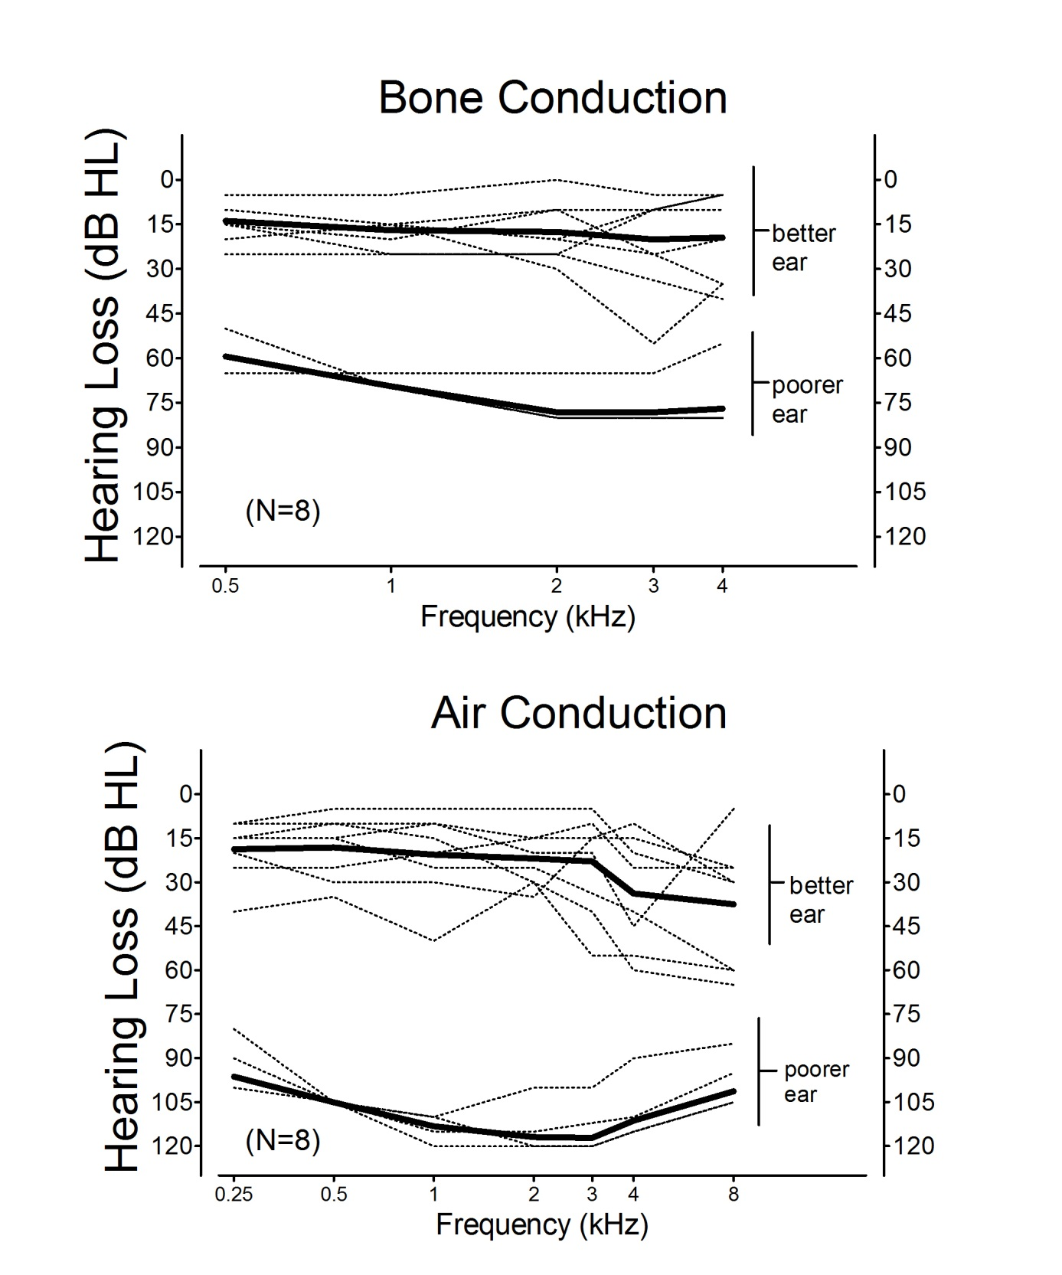

Figure 2
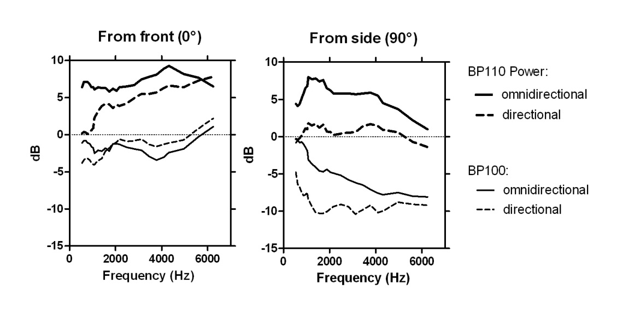

Figure 3
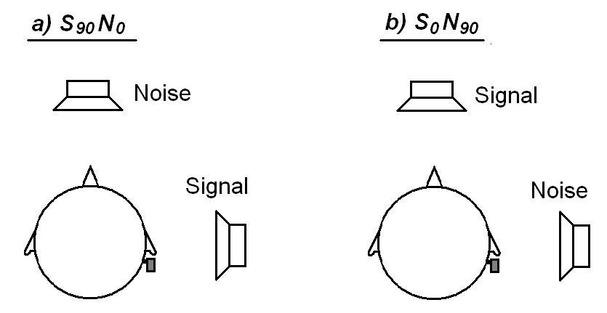

Figure 4

